Unit Assessment Whole Pod Practice
Summarizing Whole Pod Practice
Pod Member Roles Defined:
Pod Member 1 (split role with PM5 if needed): Read the ENTIRE passage; Circle the TOPIC, underline the MAIN IDEA, and double underline all KEY POINTS
Pod Member 2: Create a title using the main idea.
Pod Member 3: Write a one sentence summary of the passage that includes the main idea and all key points.
Pod Member 4: Approve or provide corrections to title and summary as needed.

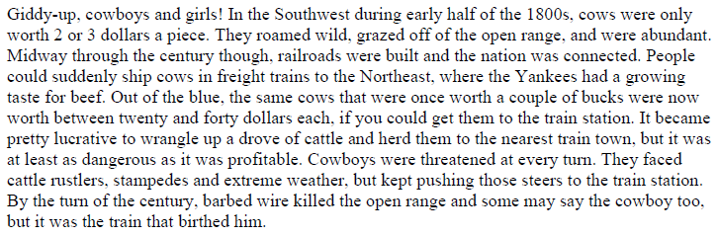
1. Title of Passage:_____________________________________________________________________
2. Summary:__________________________________________________________________________
_____________________________________________________________________________________

Point of View Whole Pod Practice:

Pod Member Roles Defined:
Pod Member 4 (split role with PM5 if needed): Read the ENTIRE passage; Underline pronouns and names of characters during reading.
Pod Member 3: Identify mode of 3rd person narration (*NOTE* there is one of each 3rd POV)
Pod Member 2: Explain how they reached that conclusion, or correct and explain.
Pod Member 1: Approve or provide corrections to mode of narration and explanation as necessary.
Rotate roles clockwise for each passage (3, 2, 1, 4 then 2, 1, 4, 3).

Urusla looked at herself in the mirror. She thought that the dress fit her very well. She turned to the saleswoman. The saleswoman thought that the dress did not fit Ursula, but she had learned a long time ago to be careful when telling customers that a dress was too small for them. Ursula asked the saleswoman, “Well? What do you think?” The saleswoman nodded, put up her thumbs, and said, “It looks stunning, ma’am.” This response made Ursula feel good about the dress, so she decided to buy it.
3. Narrators Perspective:________________________________________________________________
4. Explanation of how you know:__________________________________________________________
_____________________________________________________________________________________
King Lenny surveyed his court. He liked what he saw. The court was lined with his loyal followers, all of them hanging on his every word. “The king is the thing today, Jeoffrey,” King Lenny said to his servant. Jeoffery chuckled and said, “Today and every day, sire.” King Lenny laughed and took off his gloves. He hated wearing gloves when he was holding court. All of the complaining and the tight gloves made his palms too sweaty. “Bring in the first petitioner.” said King Lenny. He wanted to finish the boring part of his day.
5. Narrators Perspective:________________________________________________________________
6. Explanation of how you know:__________________________________________________________
_____________________________________________________________________________________
A man in a trench coat walked into a bank. A few of the tellers looked up at him as he entered, but they soon resumed their tasks. He waited in line behind an old man and a lady with a small dog. The old man walked to the counter with a jar of pennies, poured them on the counter, and began counting them slowly, “1, 2, 3…” The man in the trench coat groaned loudly, then reached I his coat and pulled out a magazine. He started reading the magazine while the old man was counting.
7. Narrators Perspective:________________________________________________________________
8. Explanation of how you know:__________________________________________________________
_____________________________________________________________________________________

Text Structure Whole Pod Practice

Pod Member 1: Read ENTIRE passage
Pod Member 2: Identify text structure
Pod Member 3: Approve or make correction to text structure selection.
Pod Member 4: Record passage number next to the given text structures.
Rotate roles counter clockwise for each passage (2, 3, 4, 1; 3, 4 ,1, 2; etc.)
_____Cause and Effect
_____Compare and Contrast
_____Problem and Solution
_____Sequence - Chronological
_____Sequence - Process

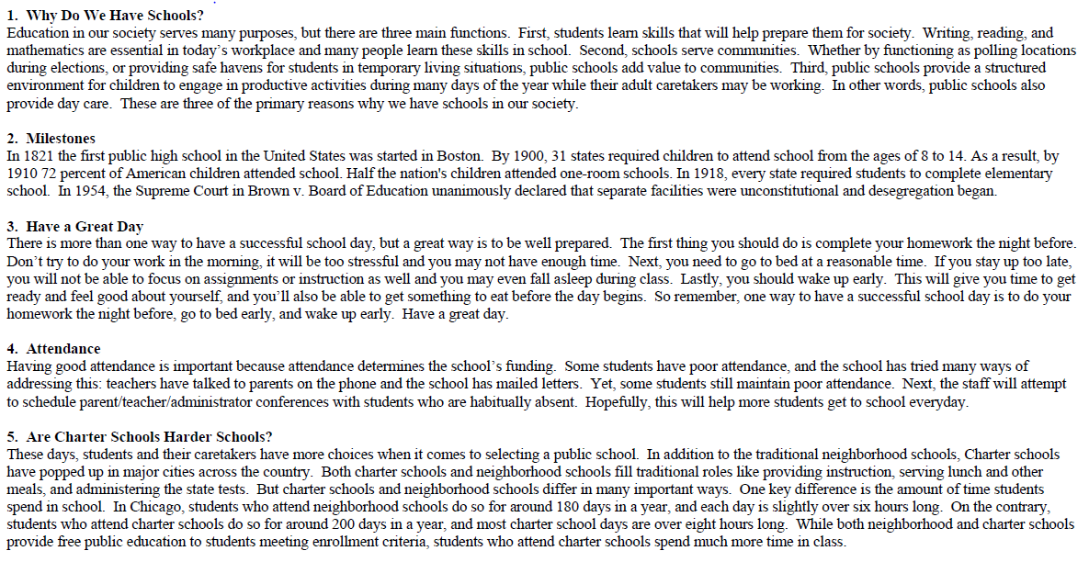
Inferencing Whole Pod Practice:
***All pod members should discuss each of the responses and offer support to their peers while completing this activity. The pod members assigned the question are simply responsible for recording the whole pod’s response to each question. ***
Pod Member 1: Read each of the questions below, then read the ENTIRE passage. Underline any part of the text your pod members identify as important for making inferences about this passage in connection to their assigned questions.
Every day after work, Paul took his muddy boots off on the steps of the front porch. Alice would have a fit if the boots made it so far as the welcome mat. He then took off his dusty overalls and threw them into a plastic garbage bag; Alice left a new garbage bag tied to the porch railing for him every morning. On his way in the house, he dropped the garbage bag off at the washing machine and went straight up the stairs to the shower as he was instructed. He would eat dinner with her after he was “presentable,” as Alice had often said.
6. Pod Member 2:
What type of job does Paul do?_________________________________________________________________________________________________________
How do you know?___________________________________________________________________________________________________________________
___________________________________________________________________________________________________________________________________
___________________________________________________________________________________________________________________________________
7. Pod Member 3:
Describe the type of person Alice is.:_____________________________________________________________________________________________________
Provide evidence from the text that supports this conclusion._________________________________________________________________________________
___________________________________________________________________________________________________________________________________
___________________________________________________________________________________________________________________________________
8. Pod Member 4:
What relationship do Paul and Alice have?________________________________________________________________________________________________
Provide evidence from the text that supports this conclusion._________________________________________________________________________________
___________________________________________________________________________________________________________________________________
___________________________________________________________________________________________________________________________________

